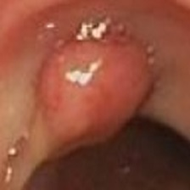

**特征分类**

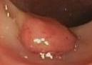

**Selective Search**

**目标框生成**

**特征提取**

**Feature X**

**对比学习**



**Image classification scores**

**目标检测**

**特征分割**

**Segmentation map S**

**fc6**

**Pseudo-label**



∧

**Dm**

**Pseudo-label**

**Heatmap Sdet**



**Dseg**

**Pooled feature**

**...**



**Input image I**

**fc7**

**Proposal scores**

**Xc=Dr**

**xd**

**Dm**